**Task 1 –**

**Algorithm**

**Psudocode**

**Code(javascript)  
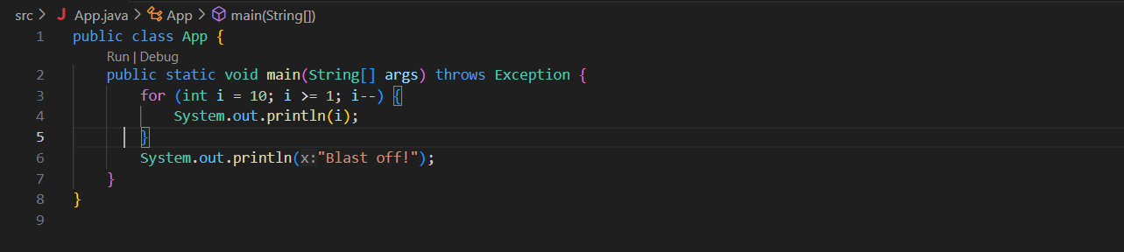**

**Output (test case 1)**

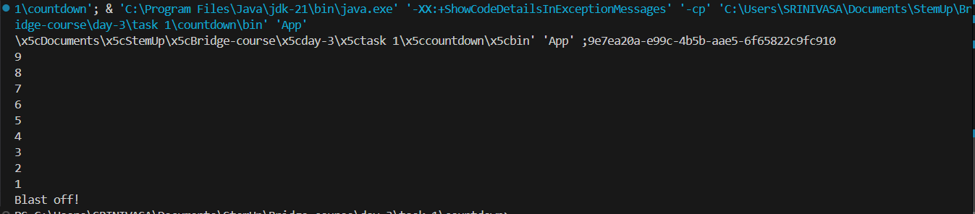

**Output (test case 2)**

**Output (test case 3)**

**Observations**

**Task 1 –**

**Algorithm**

**Psudocode**

**Code(javascript)  
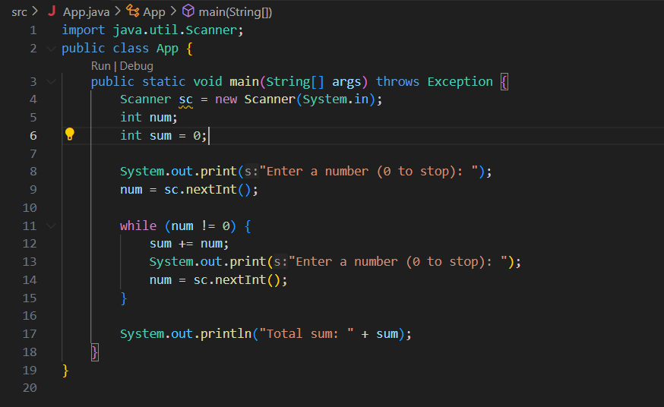**

**Output (test case 1)**

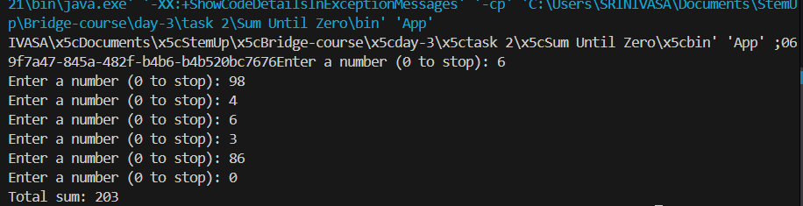

**Output (test case 2)**

**Output (test case 3)**

**Observations**

**Task 1 –**

**Algorithm**

**Psudocode**

**Code(javascript)**

**Output (test case 1)**

**Output (test case 2)**

**Output (test case 3)**

**Observations**

**Task 1 –**

**Algorithm**

**Psudocode**

**Code(javascript)**

**Output (test case 1)**

**Output (test case 2)**

**Output (test case 3)**

**Observations**

**Task 1 –**

**Algorithm**

**Psudocode**

**Code(javascript)**

**Output (test case 1)**

**Output (test case 2)**

**Output (test case 3)**

**Observations**